Collection Point – Casual Assistant
15 October 2024

Reporting Relationship and Location
Reports to: |  |  | Operations Manager – Collection Point
Team I Business Unit: |  |  | Collection Point | Property and Commercial

Purpose
Provide a high level of service to customers collecting off airport and on airport duty free pre purchased and GST zero rated goods. Efficiently receive and organise deliveries and bring to the storage facility to make available for later collection by customers. This will involve logistical functions in receiving and handing over in terminal whilst meeting airport worker requirements and regulations.
Key Accountabilities
Shift Responsibility | - On time to the shift start and well presented in the airport uniform.  - Ensure all deliveries from carriers are received into storage correctly and any issues raised immediately with the retailers who dispatched the goods.  - Meet and greet customers warmly whom are to collect their pre purchased duty/tax free goods. Make certain the validation of customer identity prior to handover of duty free goods at collection point sites.  - Liaise with and support the Collection Point Team Leader in the handling of duty/tax free goods.  - Complete all transactions within the Logistics Portal including handouts, receiving, storing and claims.  - Meeting all duty free requirements of a Customs Controlled Area
Customer Service | - High level of customer service to provided to all guests of the Collection Point and those of the wider airport community.  - Ensure accurate recording of transactions and attention to detail that confirms the customers identity prior to handover of duty free parcels.  - Ability to work under pressure and multi task when heavy volumes of orders need to be processed efficiently.  - Prepare and store goods appropriately in the back of house prior to collection.  - Develop and maintain a close working relationship with all AIAL departments, partners and collection point retailers.  - Assist guests of the airport on precinct as and when required.
Health, Safety and Wellbeing | - Role model Auckland Airport’s commitment to “People First” Health, Safety & Wellbeing approach  - Lead by example, demonstrating and communicating visibly safe work.  - Ensure all incidents are reported and investigated in a timely manner to enable continuous learning and improvement.  - Consult, engage and communicate within your team and to others, to manage and improve Health, Safety and Wellbeing.  - Understand and communicate the health, safety and wellbeing risks and controls across all the work your team carry out and maintain high levels of risk awareness within your team.
Financial Responsibilities and Authorities
Financial Authority
- Not accountable for expenditure budget. No authority to commit routine expenditure or capital expenditure without reference to people leader.
Structure Chart
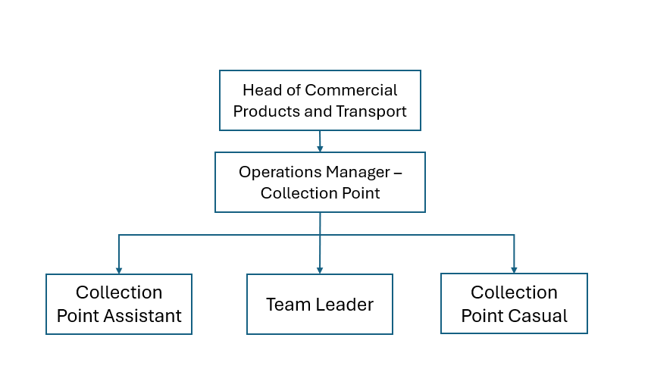

Key Challenges
- Managing the peak periods where high volumes of customers visit Collection Point needing to pick up their items within a tight time frame to reach the gate and meet the boarding time.
- Maintaining accuracy of record keeping throughout handout procedure especially to make certain the duty free is provided to the right person
- Completing receipt of all deliveries making certain that appropriate screening and accurate transacting is completed and reporting of any discrepancies immediately.
Key Relationships
Internal |  |  |  |  | Purpose of contact with this person/s
- Collection Point Team Leader and assistants  - Operations Manager and Leadership Team  - Airport operations and contact centre |  |  |  |  | - Team work with colleagues is essential to a successful shift where customers are well served and workload is shared.  - To fulfil the business requirements and documentation is completed correctly per our Customs licence.
External |  |  |  |  | Purpose of contact with this person/s
- Customers  - Passengers  - Airlines/Ground Handlers  - Retailers  - Carriers  - Border Agencies |  |  |  |  | - Customers are the key stakeholders whom are the first priority  - Collection Point handles pre sold goods on behalf of retailers so we must replicate the high level of service they have experienced, plus guide retailers on how Logistics Portal operates.  - Work in with carriers to ensure deliveries are picked up in a timely manner and received in.  - Adhere to the airport worker rules and legislation under which Aviation Security and NZ Customs operate.
Person Specification
Qualifications (or equivalent level of learning)
Essential |  |  |  |  | Desirable
- NZ Diploma NCEA level 2 or above |  |  |  |  | - Certificate / Diploma in travel and tourism hospitality
Knowledge / Experience
Essential |  |  |  |  | Desirable
- Knowledge of aviation industry  - Customer experience minimum 1 year retail  - Computer literate  - Clear and concise phone manner  - Ability to converse with people of different cultures  - Attention to detail  - Administrative details with capacity to follow standard operating procedures. |  |  |  |  | - Certificate / Diploma in travel and tourism hospitality  - Multi lingual
Key Skills / Attributes / Job Specific Competencies
Level |  |  |  |  | Skill / Attribute / Competency
Expected  Expert Level  Working Knowledge  Advanced  Developing |  |  |  |  | Reliable for shift work and conscientious  Customer Service Experience  Documentation and transaction recording  Customer claims and complaint handling  Duty Free Customs allowances
Values
Whiria te tangata. Our values weave us together. They’re what we stand for, who we are and how we think, feel and act.
  All in  Tātou tātou |  | - People first  - Seek understanding  - Acknowledge others  - Empathise and support  - Diverse & inclusive
  Know How  Kōkiri Tahi |  | - Explore and solve together  - Curious and open  - Bring your voice & share your skills  - Unite and collaborate  - Right people in the room
  Let’s Go  Karawhiua |  | - Challenge yourself  - Take pride  - Act with intent and integrity  - Keep your word  - Deliver excellence
Changes to Position Description
From time to time it may be necessary to consider changes in the position description in response to the changing nature of Auckland Airport’s work environment, including technological requirements or statutory changes. This position description may be reviewed as part of the preparation for performance planning for the annual performance cycle, or as required.
Sign-Off
Job-Holder |  |  |  | People Leader
Print Name: _________________________  Sign: _________________________ |  |  |  | Print Name: _________________________  Sign: _________________________

